**MEDICAL INVENTORY MANAGEMENT**

**College Name : KPR COLLEGE OF ARTS SCIENCE AND RESEARCH**

**College Code : bruaz**

**TEAM ID :**

**TEAM MEMBERS :**

**Team Leader Name : Dhanya P**

**Email :** [**23bda012@kprcas.ac.in**](mailto:23bda012@kprcas.ac.in)

**Team Member 1 : Dharanish K T**

**Email : 23bda013@kprcas.ac.in**

**Team Member 2 : Hareni N**

**Email : 23bda016@kprcas.ac.in**

**Team Member 3 : Harish E**

**Email : 23bda017@kprcas.ac.in**

**1. INTRODUCTION**

**1.1 Project overview**

This project is a comprehensive Salesforce application to streamline and manage various operational aspects of medical inventory. The system aims to efficiently maintain supplier details, manage purchase orders, track product details and transactions, and monitor the expiry dates of products.

**1.2 Purpose**

Maintain detailed records of suppliers, including contact information. Catalog product information, including descriptions, stock levels. Monitor and track product expiry dates to avoid using expired items. Comprehensive reports to track supplier performance, and purchase orders.

**2. DEVELOPMENT PHASE**

### Creating Developer Account

### By using this URL -  <https://developer.salesforce.com/signup>

### 

* **Creating Objects:** Product,Purchase Order, Order Item, Inventory Transaction and Supplier

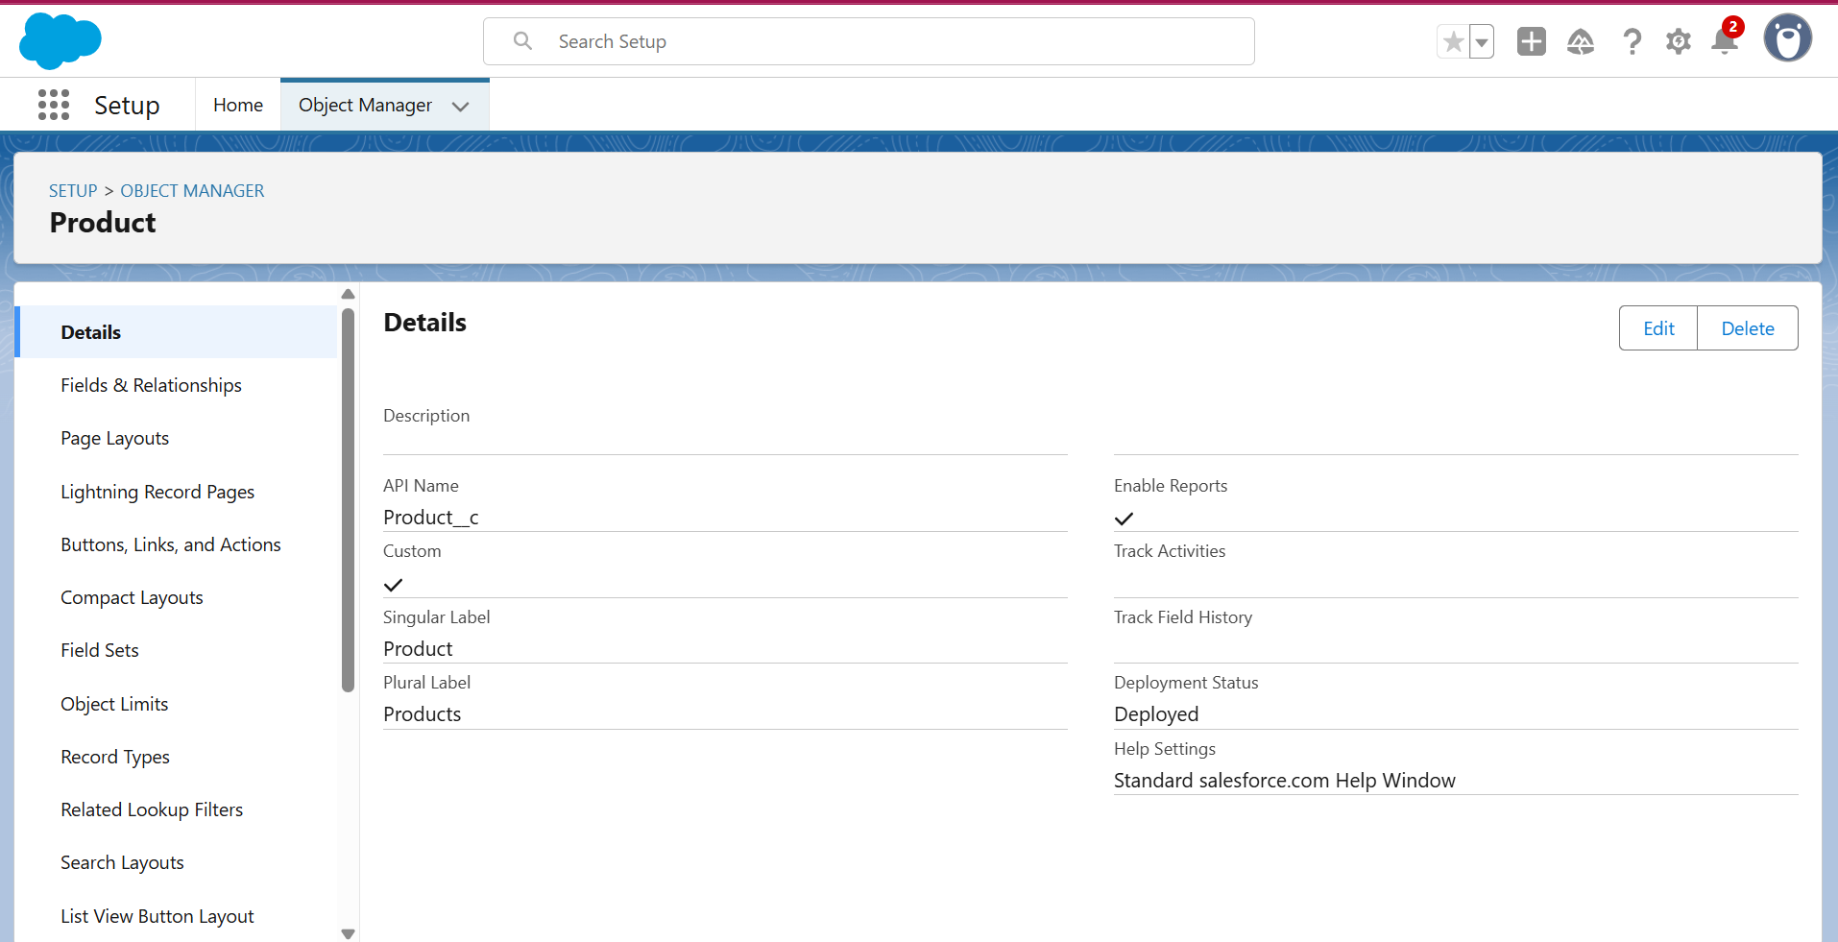

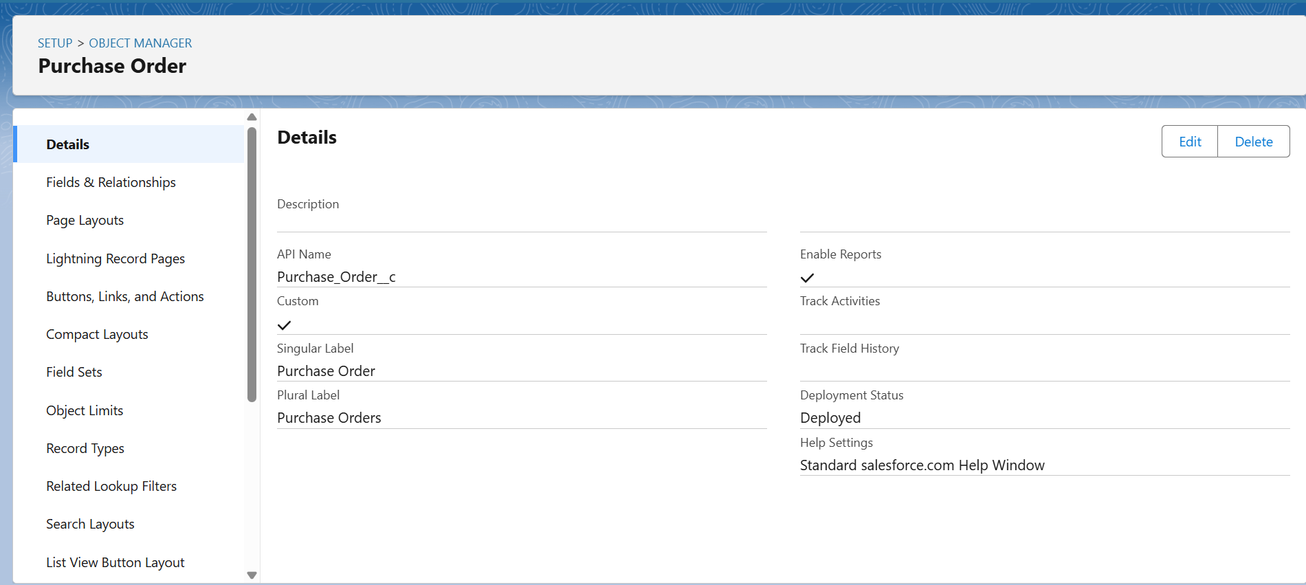

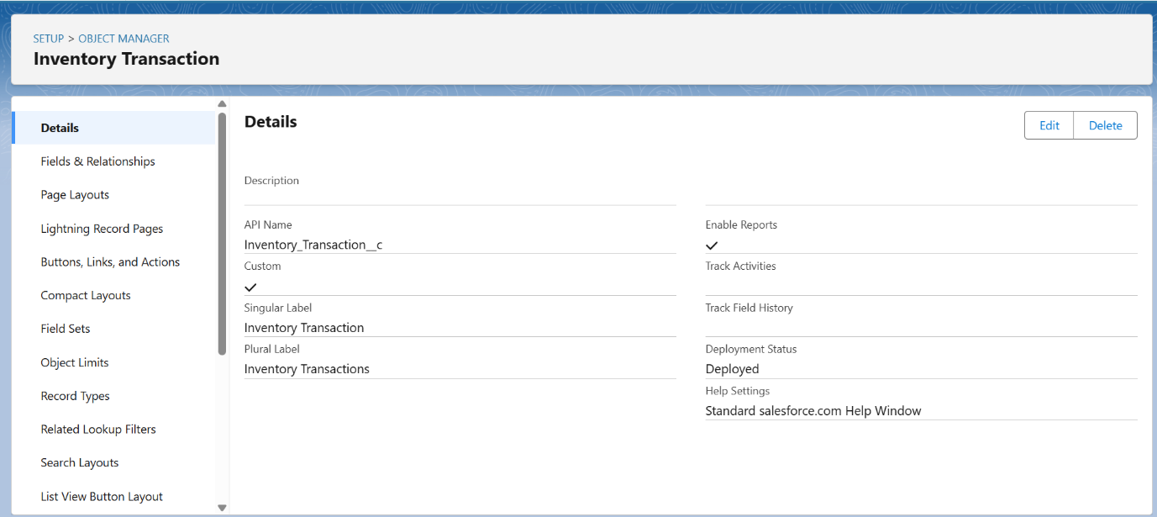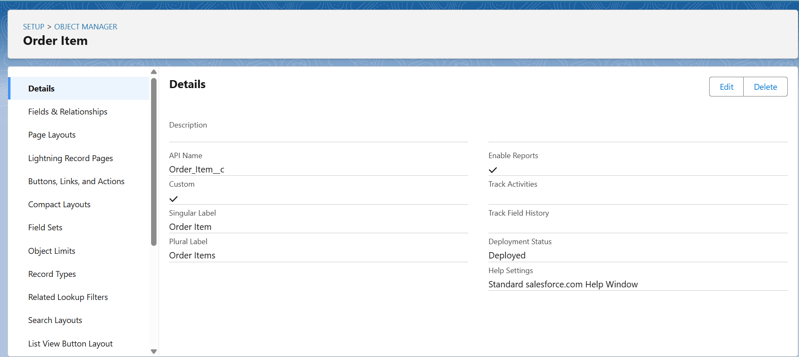

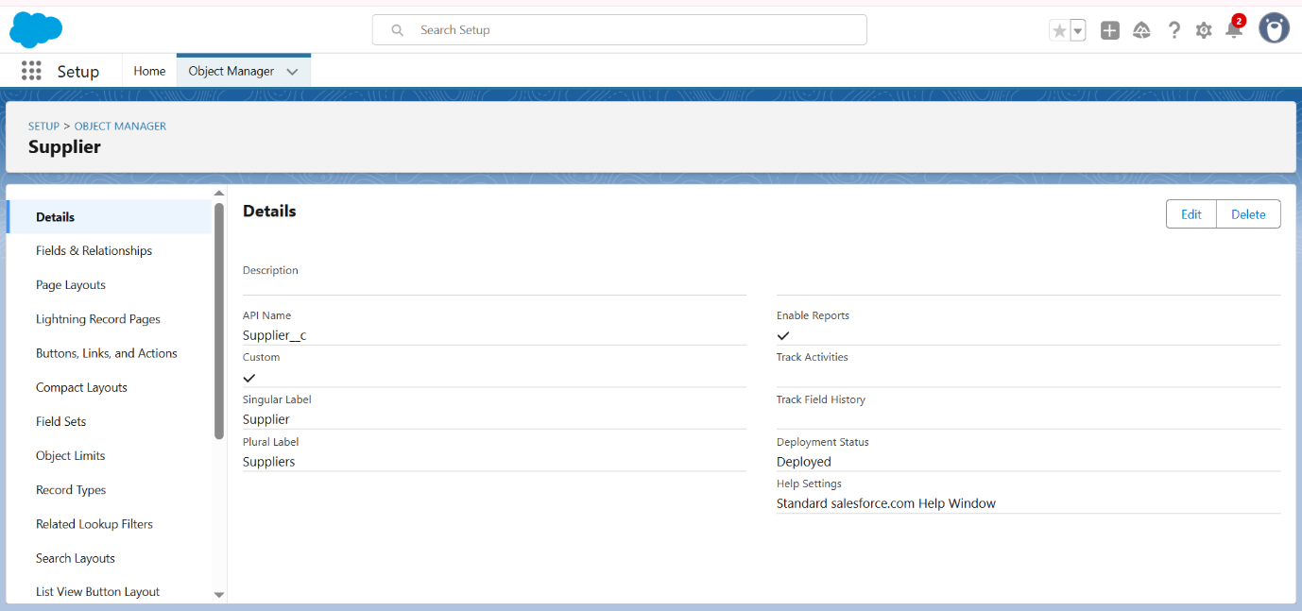

### Creating a tab for Objects : Product, Purchase Order, Order Item, Inventory Transaction and Supplier.

### 

### 

### 

### 

### Create a Lightning App for Medical Inventory Management

### 

### 

### 

### Creating Fields and Relationships

### 

### 

### 

### 

### 

### To edit a Page Layout in Product Object

### To edit a Page Layout in Purchase Order Object

### 

### To edit a Page Layout in Order Item Object

### 

### To edit a Page Layout in Inventory Transaction Object

### 

### To edit a Page Layout in Supplier Object

### 

### To create a Compact Layout to a Product Object

### 

### To create a Compact Layout to a Purchase Order Object

### 

### To create an Expected Delivery Date Validation rule to a Employee Object

### 

### To create an Inventory Manager Profile

### 

### To create an Purchase Manager Profile

### 

### Create a Purchasing Manager and Inventory Manager Role

### 

### Create a Permission Set

### 

### 

### Create Flow to update the Actual Delivery Date

### 

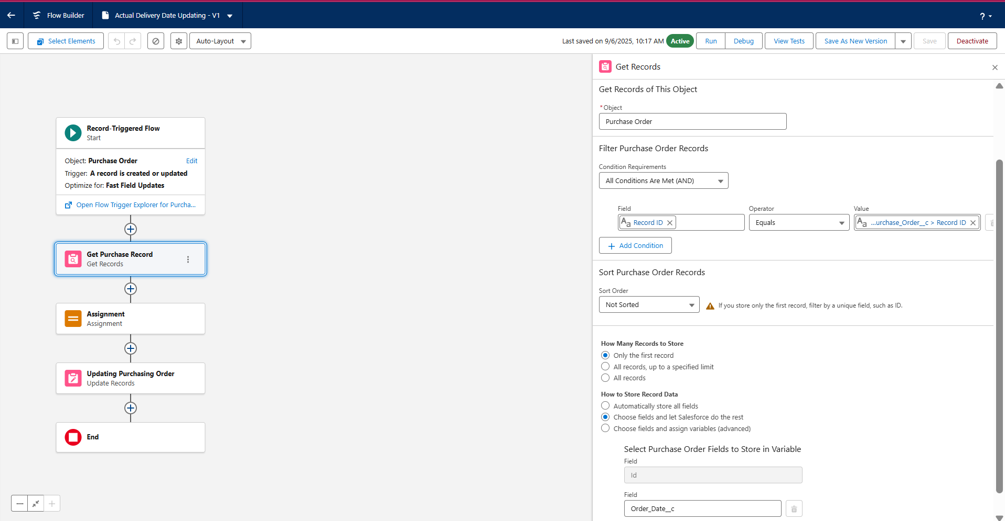

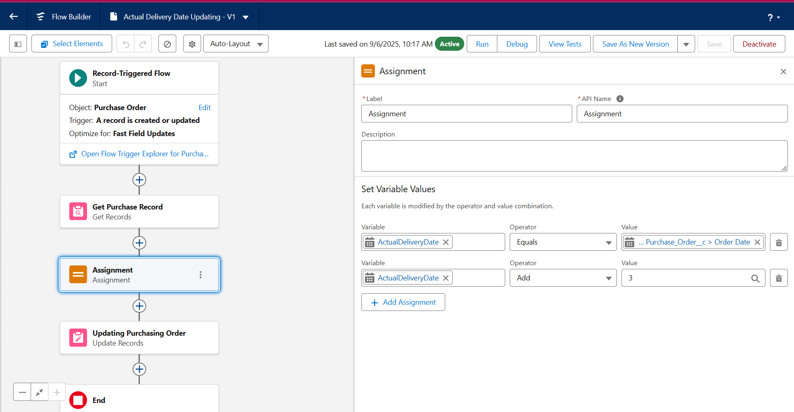

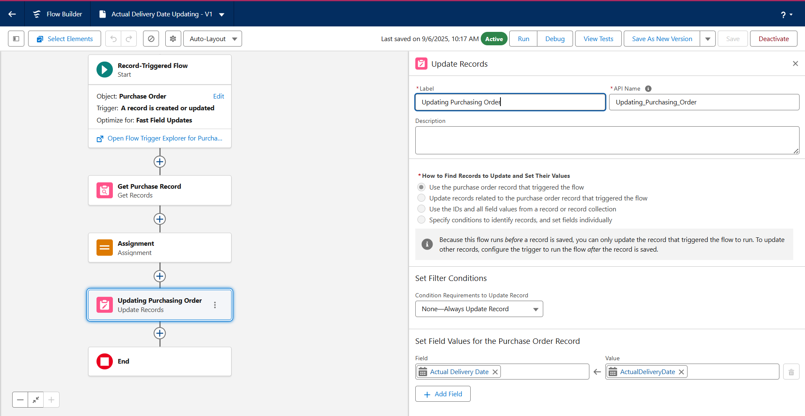

### Create a Trigger to Calculate total amount on Order Item

### 

### Create a Purchase Orders based on Suppliers(Summary) Report

### 

### Create a Complete Purchase Details Report

### 

### Create and View Medical Inventory Dashboard

### 